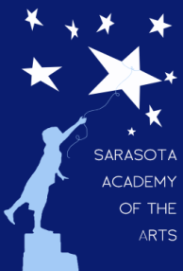
Sarasota Academy of the Arts
4466 Fruitville Road
Sarasota, FL 34232
www.sarasotaacademyofthearts.com
(941) 377-2278 FAX (941) 404 – 4492

SAA March Governing Board Meeting Agenda

8:10 AM – Call to order (front art room)
Review/approval of minutes
Treasurer’s Report/Financials
Principal’s Report
New Business
Adopt public comment rules
Old Business

