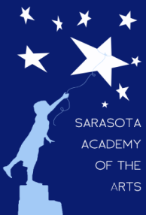
Sarasota Academy of the Arts
4466 Fruitville Road
Sarasota, FL 34232
www.sarasotaacademyofthearts.com
(941) 377-2278 FAX (941) 404 – 4492

June 6, 2016 (Annual) Meeting Agenda
Sarasota Academy of the Arts
Governing Board

Call to order
Introduction of Guests
Reading/Approval of Minutes
Acceptance of resignation of Board member – Caroline Tanner
Approval of new Board member – Kyle Turoff
Financial Report
Principal’s Report
Old Business
Reading/approval of February 2016 minutes
Approval of Visitor Comment Procedure
School shirts
New Business
Review of Principal’s Annual Evaluation
Review of proposed salary schedule for 2016-17
Election of officers for 2016-17

