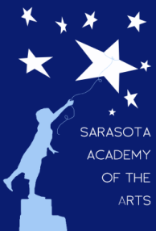
Sarasota Academy of the Arts
4466 Fruitville Road
Sarasota, FL 34232
www.sarasotaacademyofthearts.com
(941) 377-2278 FAX (941) 404 – 4492

Governing Board Agenda – January 11, 2016
Call to order
Review/Acceptance of December Minutes
Financial/Treasurer’s Reports
Principal’s Report
Old Business
Insurance
New Business

