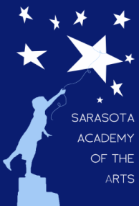
Sarasota Academy of the Arts
4466 Fruitville Road
Sarasota, FL 34232
www.sarasotaacademyofthearts.com
(941) 377-2278 FAX (941) 404 – 4492

February Governing Board Meeting Agenda
February 8, 2016
8:10 AM

Call to Order
Reading/Approval of the Minutes
Review of Rules Regarding Public Comment
Public Comment
Finance Report
Principal's Report
New Business
Request for Credit Card
Old Business

