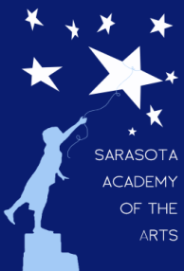
Sarasota Academy of the Arts
4466 Fruitville Road
Sarasota, FL 34232
www.sarasotaacademyofthearts.com
(941) 377-2278 FAX (941) 404 – 4492

MAY 9, 2016 GOVERNING BOARD MEETING AGENDA

Call to order
Reading/Approval of Minutes
Financial Report
Principal’s Report
New business:
Amendment to “Segregation of Financial Duties Policy”
Review/approval of Bonus payments to staff
Rules relating to Visitors Addressing Board
Old business:
Update on status of land acquisition
Governing Board Training

