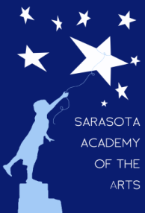
Sarasota Academy of the Arts
4466 Fruitville Road
Sarasota, FL 34232
www.sarasotaacademyofthearts.com
(941) 377-2278 FAX (941) 404 – 4492

July 18, 2016 Governing Board Meeting Agenda

(Meet in Administration Office Building, 8:00 AM)

Call to Order
Reading/approval of Minutes
Principal’s Report
Introduction of New Assistant Principal
Current Enrollment
Newly added staff
Financial Report
New Business –
Discussion/approval of amended 2016FY budget
Board compliance documents
Meeting calendar for 2017FY
Old Business –
Appointment of treasurer for 2017FY
Status of land purchase
Changes in Board Membership

