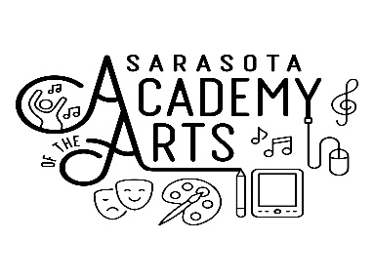
2019-2020
Sarasota Academy of the Arts
Middle School Student Acknowledgements

As a parent at Sarasota Academy of the Arts, I have read my child the following student conduct standards and understand that these must be followed at all times during school hours, including before and after school care, and at school sponsored activities whether on or off campus.

Students will follow the school wide rules regarding respect
- Respect Others
  - Speaking politely to all adults and students, using kind words that support the school’s stance of acceptance and tolerance of all people
  - Keeping my hands, feet and all other body parts to myself to include all physical acts or public displays of affection
  - Not participating in any form of bullying to include physical contact, verbal abuse, or cyberbullying including all electronic forms of messaging or social media towards any staff member or student
  - Not disrupting the learning of others through verbal comments or items brought to school that could be disruptive to the educational process
- Respect Myself
  - Completing my own work on time, to the best of my ability, as cheating is not allowed
  - Keeping myself safe, not harming myself
  - Keeping up to date with my agenda book, Google Classroom, Big Ideas, Discovery Science and other assignments
  - Adhering to the school dress code as outlined in the students’ handbook
  - Arriving to school and classes on time and staying till the end of the day
  - Asking for and completing makeup work when absent from class in a timely manner
  - Not bringing, using, distributing or having in possession any alcohol, tobacco products, juuls, drugs of any kind, weapons, or materials that could be used as weapons
  - Not using cell phones during school hours (7:30 am - 4:00 pm)
- Respect the School (staff and facilities)
  - Using all classroom materials in the manner in which they should be used
  - Using school textbooks, furniture, building, grounds and equipment properly and free from vandalism
  - Using school assigned electronics for learning purposes only as assigned by school staff

Students must also follow all rules in the SAA Student Handbook and the Sarasota County Student and Family Handbook. https://www.sarasotacountyschools.net/departments/dop/handbook.aspx

I understand that if my student does not follow the SAA Student Handbook, they may be dismissed from SAA as outlined in the Dismissal Policy and Procedures in the Student Handbook.

I have read all of the above with my child.

Student Name_________________________________________________ Grade________________

Parent Signature_______________________________________________ Date ________________

