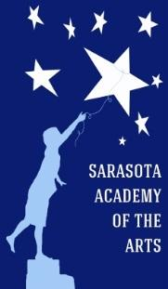
Sarasota Academy of the Arts
Re-Enrollment Commitment Form
For the 2018-2019 School Year
Return by February 16th, 2018
(for Returning SAA Students ONLY)

Please Note:
- A separate form must be filled out for each student re-enrolling.
- This form must be returned to the SAA main office and date stamped by 5:00 PM on February 16, 2018, in order for your student’s spot to be guaranteed for the 2018-2019 school year.
- InfoSnap is a more detailed on-line enrollment for Sarasota County Schools that will need to be filled out at a later date.

Student’s First Name: | Last Name: | Grade Entering:
Sibling’s Name:  Does sibling attend SAA? YES NO  2018-2019 Grade:  School attending: | Sibling’s Name:  Does sibling attend SAA? YES NO  2018-2019 Grade:  School attending:: | Sibling’s Name:  Does sibling attend SAA? YES NO  2018-2019 Grade:  School attending:

_____ My child will not return to SAA for the 2018-2019 school year.

Parent’s Name:
Parent’s Signature: Date:

4466 Fruitville Road
Sarasota, FL 34232
Phone: 941-377-2278 FAX: 941-404-4492
www.SarasotaAcademyoftheArts.com

Date & Time Received in the SAA Office:

