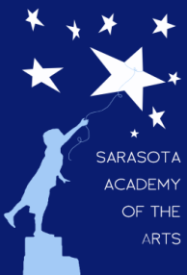
Sarasota Academy of the Arts
4466 Fruitville Road
Sarasota, FL 34232
www.sarasotaacademyofthearts.com
(941) 377-2278 FAX (941) 404 – 4492

April 11, 2016 Governing Board Meeting Agenda

Call to order
Finance/Treasurer’s Report
Reading/Approval of February minutes (no March meeting)
New Business
Rules relating to Visitors’ Addressing Board
Property Acquisition
School Uniforms
Old Business
Governing Board training

